## Assignment

<http://apmonitor.com/pdc/index.php/Main/DeriveBalanceEquations>

### Exercise 1: ****Mixer Transient Species Balance****

There are two inlet streams to a well-mixed and constant volume vessel. The flow rate is (qi) and concentration is (ci) for all streams (i=1,2,3). **Derive a dynamic balance equation for outlet concentration and vessel liquid volume that relates to volumetric flow rates and inlet concentrations.** Follow the procedure to build a dynamic model in the modeling introduction. For the model equations, use a transient mass and species balance as shown in balance equations. State any assumptions that are needed. Simplify the equations by eliminating any unnecessary terms and express the final equations in terms of the quantities on the diagram. There is no need to simulate the dynamic response, only derive the form of the equations.

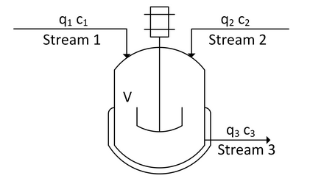

1. Objectives: Predict concentration coming out (c3) and predict the volume (V).
2. Draw Schematic
3. Assumptions:
   1. It is well-mixed (idk what that means)
   2. Constant density
   3. No reactions (hence, the reaction terms in the species balance equation are ignored)
4. Determine spatial dependence (???)
5. Write dynamic balance equations (mass, species, etc…)

**Mass balance equation**

$$\frac{dV}{dt}=q_{1}+q_{2}-q_{3}$$

**Species balance equation**

$$\frac{dC_{A}V}{dt}=c_{1}q_{1}+c_{2}q_{2}-c_{3}q_{3}$$

$$C_{3}\frac{dV}{dt}+V\frac{dC_{3}}{dt}=c_{1}q_{1}+c_{2}q_{2}-c_{3}q_{3}$$

1. Other relations
   1. m = rho*V
$n_{A}=C_{A}V$

$\dot{n_{A}}=C_{A}q$

2. Degrees of freedom (num eqs == num unknowns)
3. Classify inputs as
   1. Fixed values
   2. Disturbances
   3. Manipulated variables
4. Classify outputs as
   1. States: V, C3
   2. Controlled variables

### Exercise 2: Mixer Transient Energy Balance

A vessel has one inlet and one outlet stream as shown in the diagram. Derive an expression for the temperature in a vessel.

The energy balance should consider:

* Heat loss due to convective heat transfer to ambient air at temperature Ta
* Heat transfer to the cooling jacket fluid at temperature Tc
* There is shaft work Ws
* There is no chemical reaction.

Reduce this energy balance by eliminating any terms and simplifying the expression. The liquid heat capacity and density are constant for all streams.

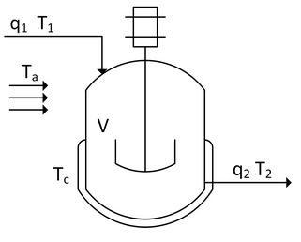

1. Objective: Predict the temperature
2. Draw schematic
3. List all assumptions
   1. Liquid heat capacity is constant
   2. Liquid density is constant
   3. No heat input (Q = 0)
   4. Constant reference temperature $T_{a}$
   5. Equal flows: $q_{1}=q_{2}$, ${\dot{m}}_{1}={\dot{m}}_{2}$
4. PDE or ODE?
   1. Well-mixed: temperature outlet is the same as temperature in the vessel
5. Write dynamic balance equations

$$\frac{dh}{dt}={\dot{m}}_{1}{\hat{h}}_{1}-{\dot{m}}_{2}{\hat{h}}_{2}+U_{a}A\left(T_{a}-T_{2}\right)+U_{c}A\left(T_{c}-T_{2}\right)+W_{s}$$

$$\frac{dh}{dt}={\dot{m}}_{1}c_{p}\left(T_{1}-T_{a}\right)+{\dot{m}}_{2}c_{p}(-T_{2}+T_{a})+U_{a}A\left(T_{a}-T_{2}\right)+U_{c}A\left(T_{c}-T_{2}\right)+W_{s}$$

$$\frac{dh}{dt}=\dot{m}c_{p}\left(T_{1}-T_{2}\right)+U_{a}A\left(T_{a}-T_{2}\right)+U_{c}A\left(T_{c}-T_{2}\right)+W_{s}$$

$$mc_{p}\frac{d(T_{2}-T_{a})}{dt}=\dot{m}c_{p}\left(T_{1}-T_{2}\right)+U_{a}A\left(T_{a}-T_{2}\right)+U_{c}A\left(T_{c}-T_{2}\right)+W_{s} \\ ρVc_{p}\frac{dT_{2}}{dt}=ρq_{1}c_{p}\left(T_{1}-T_{2}\right)+U_{a}A\left(T_{a}-T_{2}\right)+U_{c}A\left(T_{c}-T_{2}\right)+W_{s}$$

(All inlet terms, things that make it hotter, are positive; all things that make it cooler are negative)

1. Other relations

 $m=ρV$

  2. Enthalpy is $h=mc_{p}(T-T_{ref})$ where $c_{p}$ is the heat capacity
   3. Specific enthalpy is $\hat{h}=c_{p}(T-T_{ref})$ where the units are per kilogram
2. Degrees of freedom, does number of equations = number of unknowns? -> Yeah
3. Classify inputs as
   1. Fixed values
   2. Disturbances
   3. Manipulated variables
4. Classify outputs as
   1. States: T2
   2. Controlled variables